1. Job failed because of compile errors. [SCREENSHOT01]

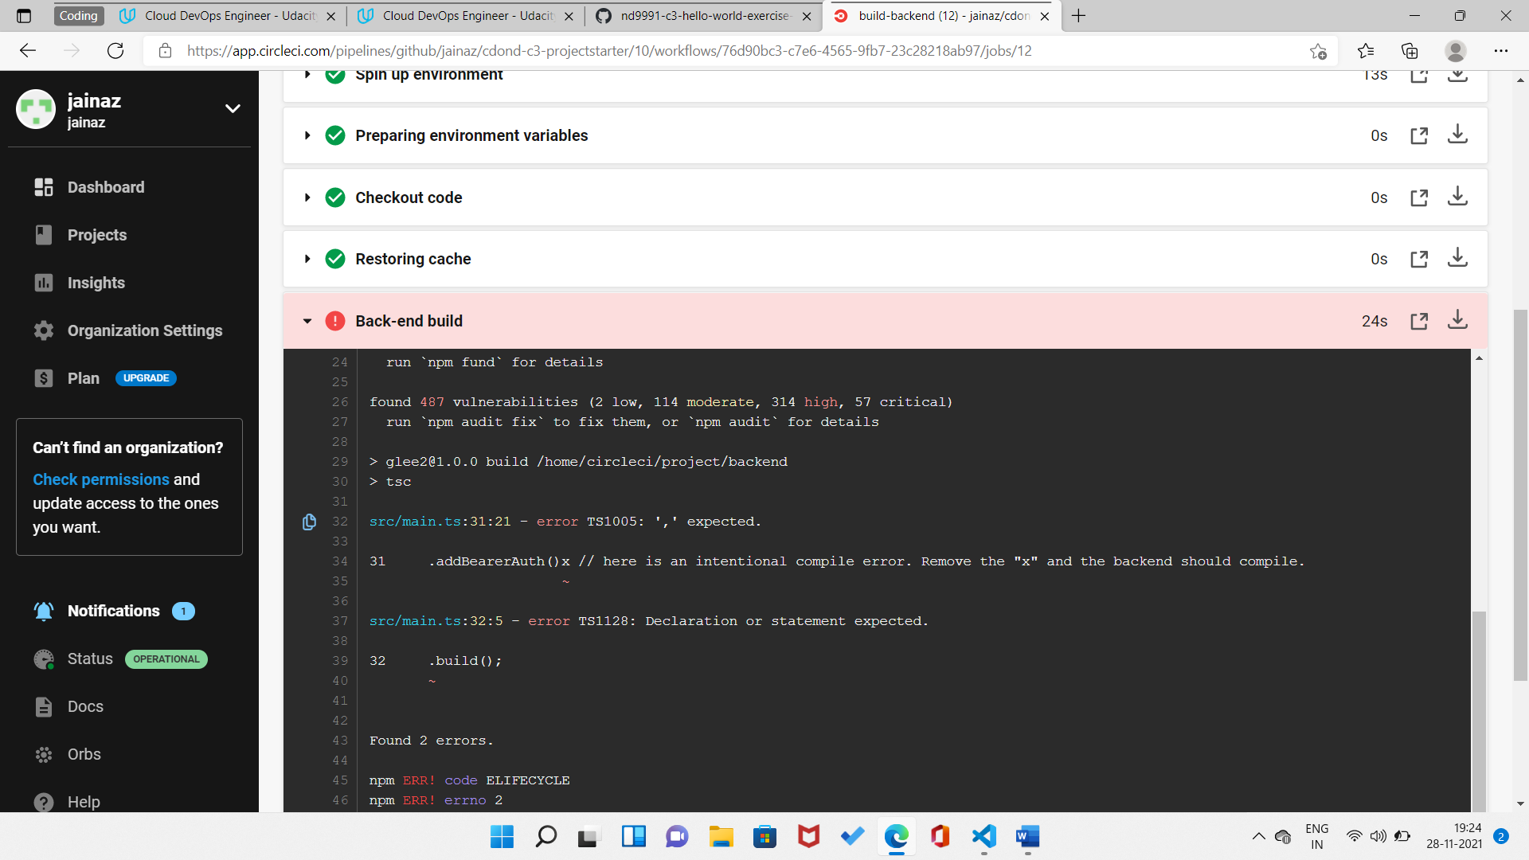

**Compilation Issue Fixed**

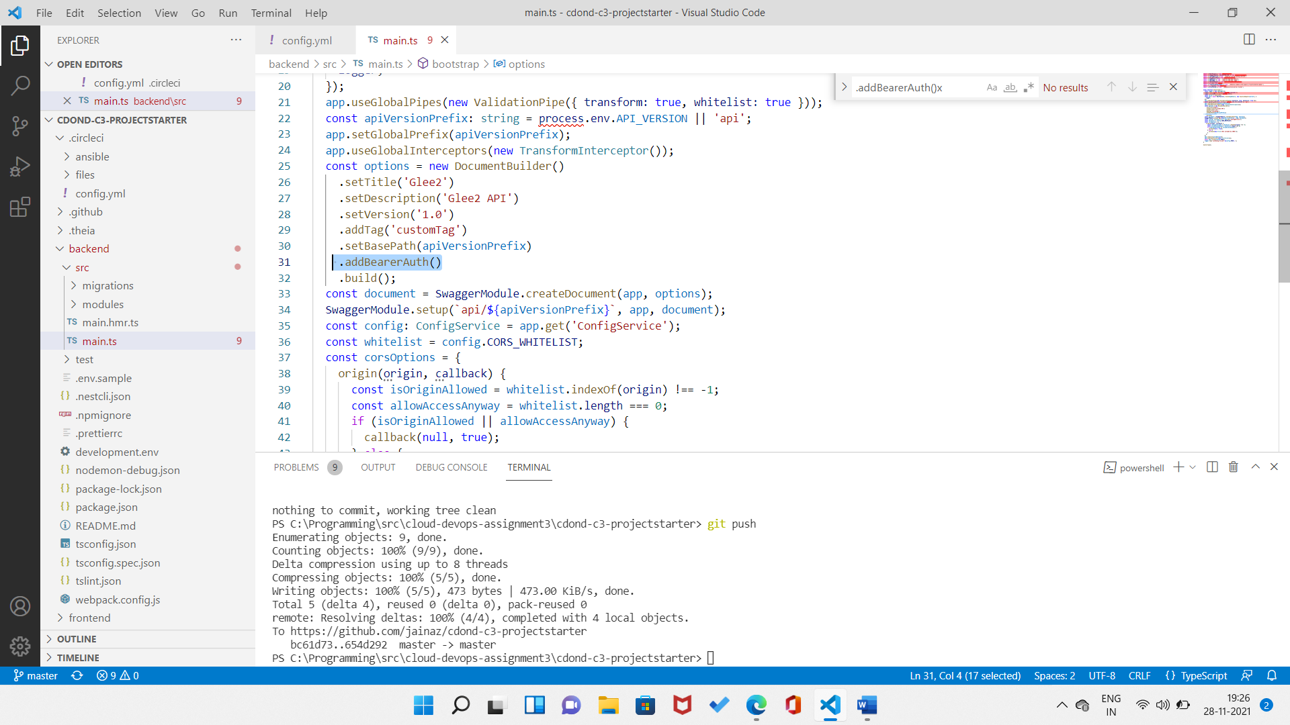

1. Job failed because of unit tests. [SCREENSHOT02]

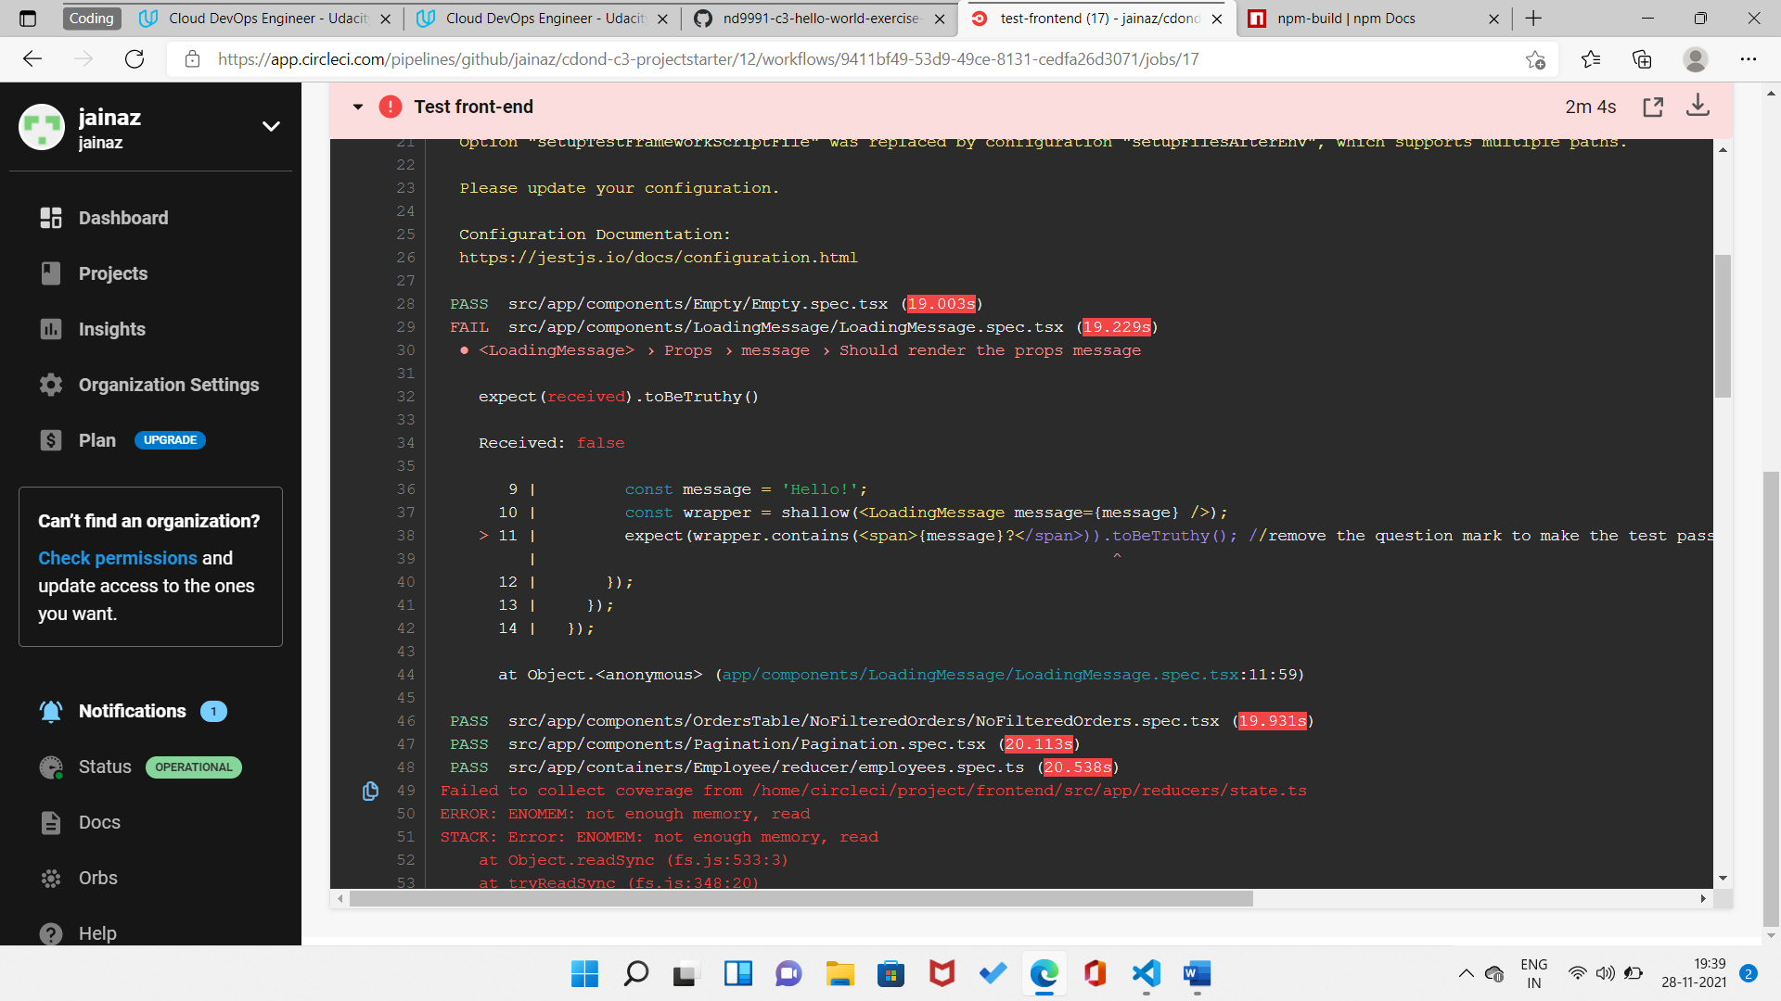

**Fixed Test issue**

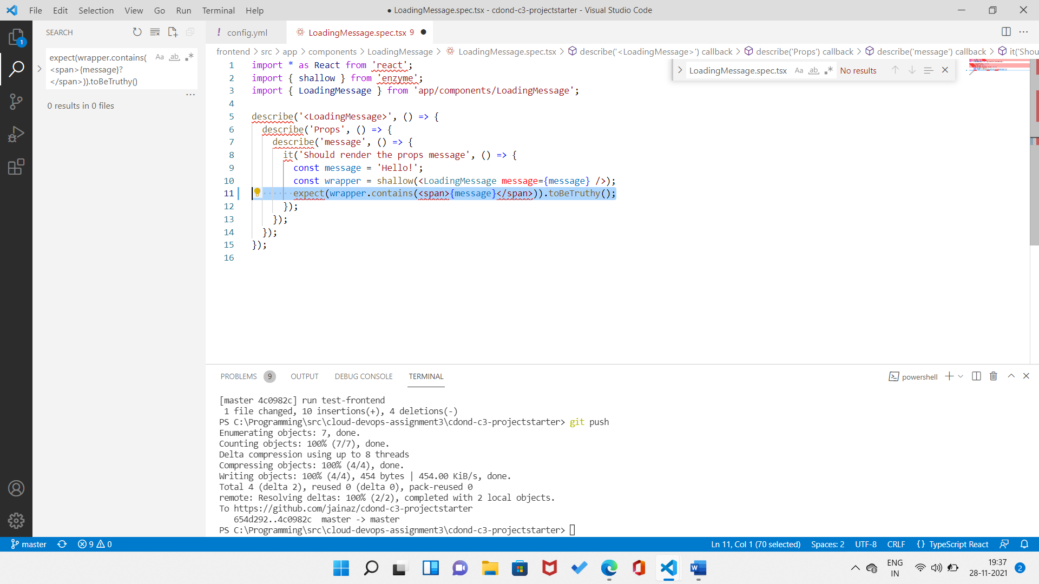

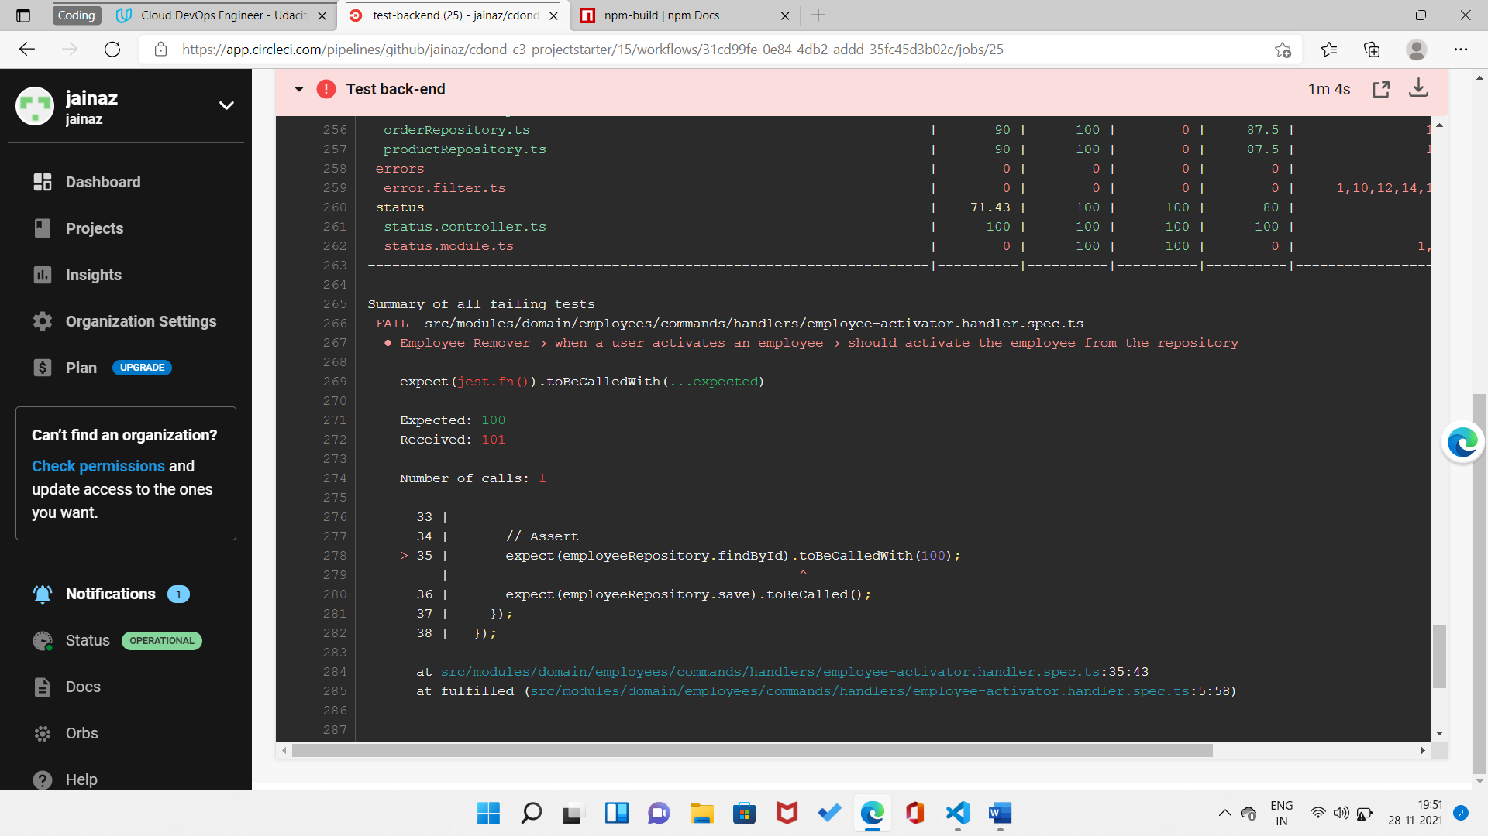

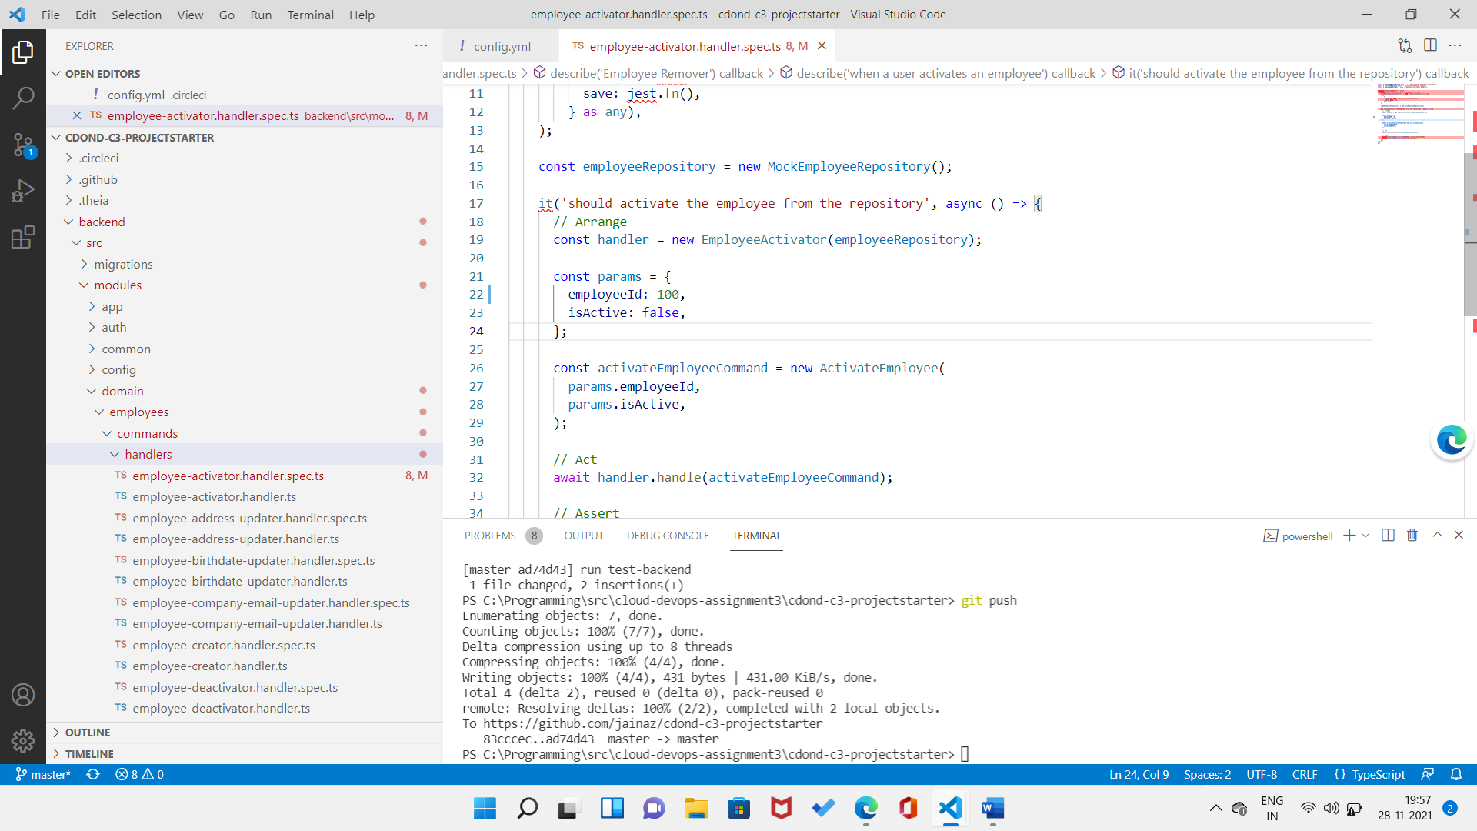

1. Job that failed because of vulnerable packages. [SCREENSHOT03]

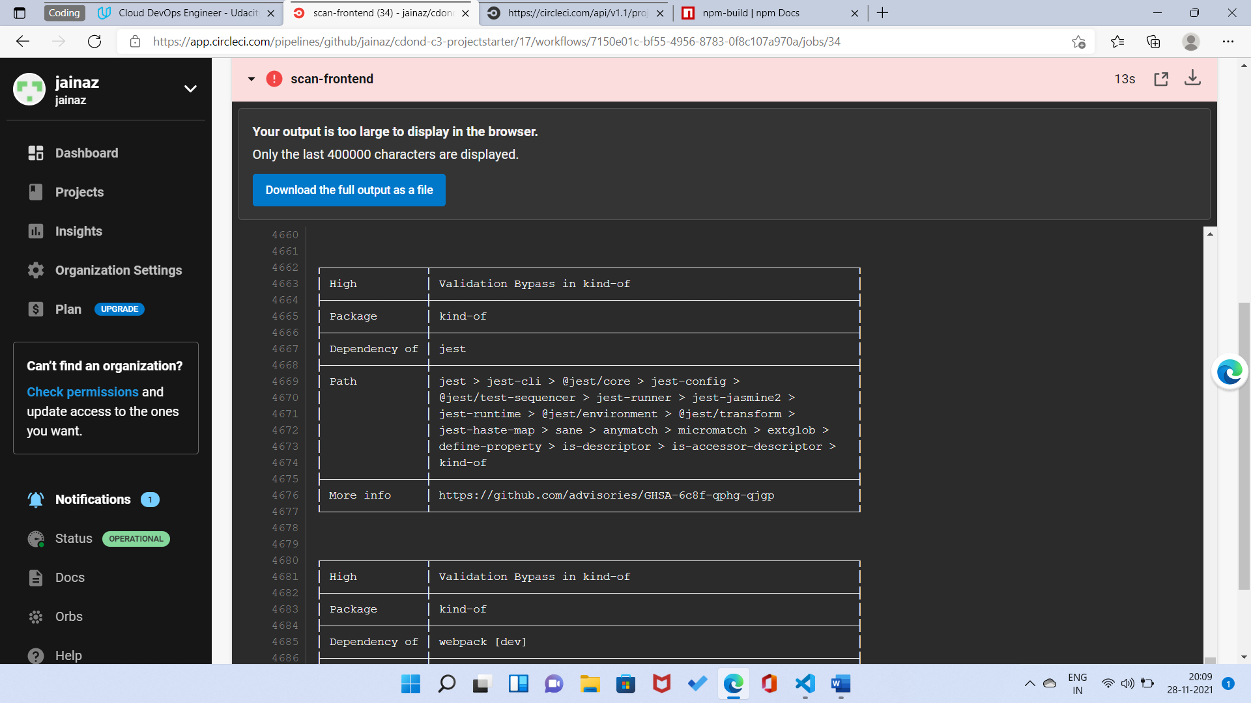

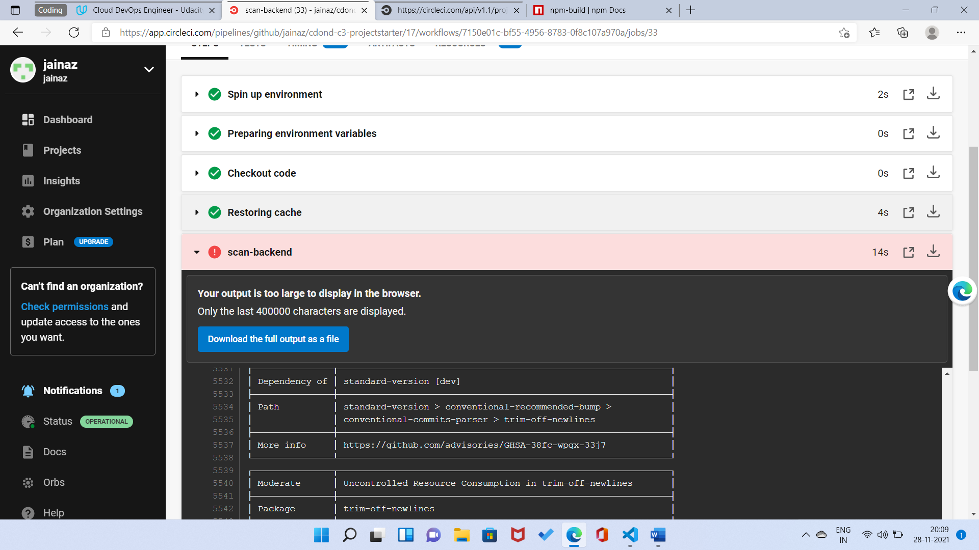

1. An alert from one of your failed builds. [SCREENSHOT04]

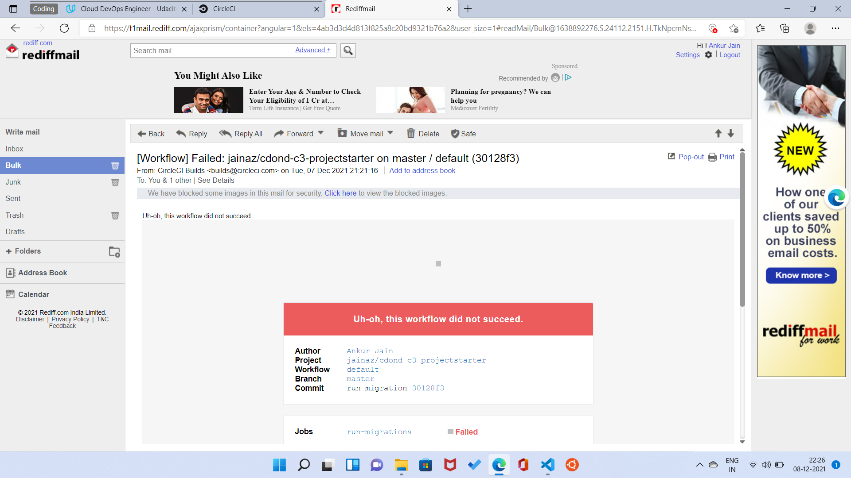

1. Appropriate job failure for infrastructure creation. [SCREENSHOT05]

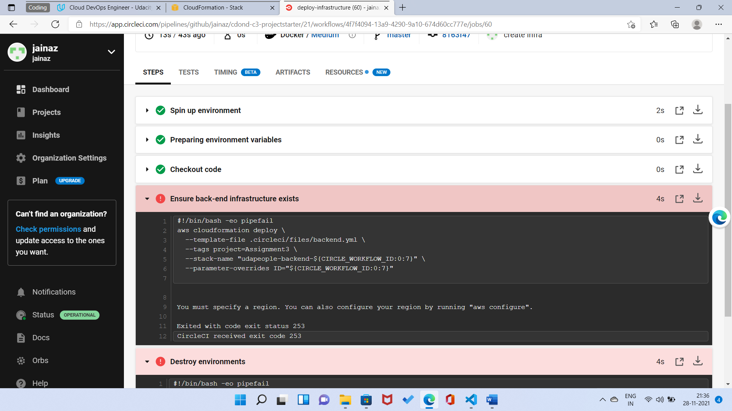

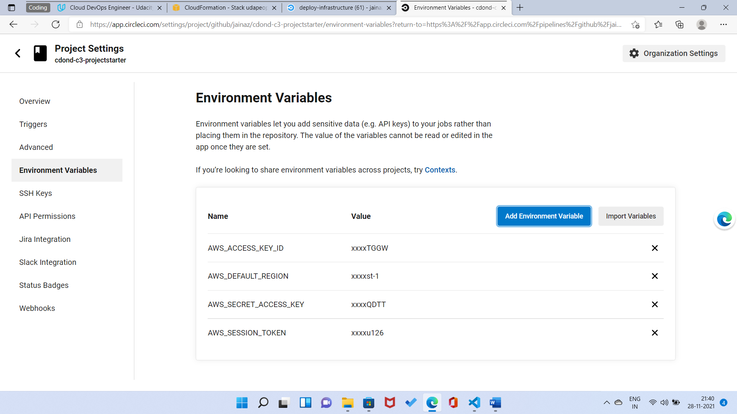

1. Appropriate job failure for the smoke test job. [SCREENSHOT06]

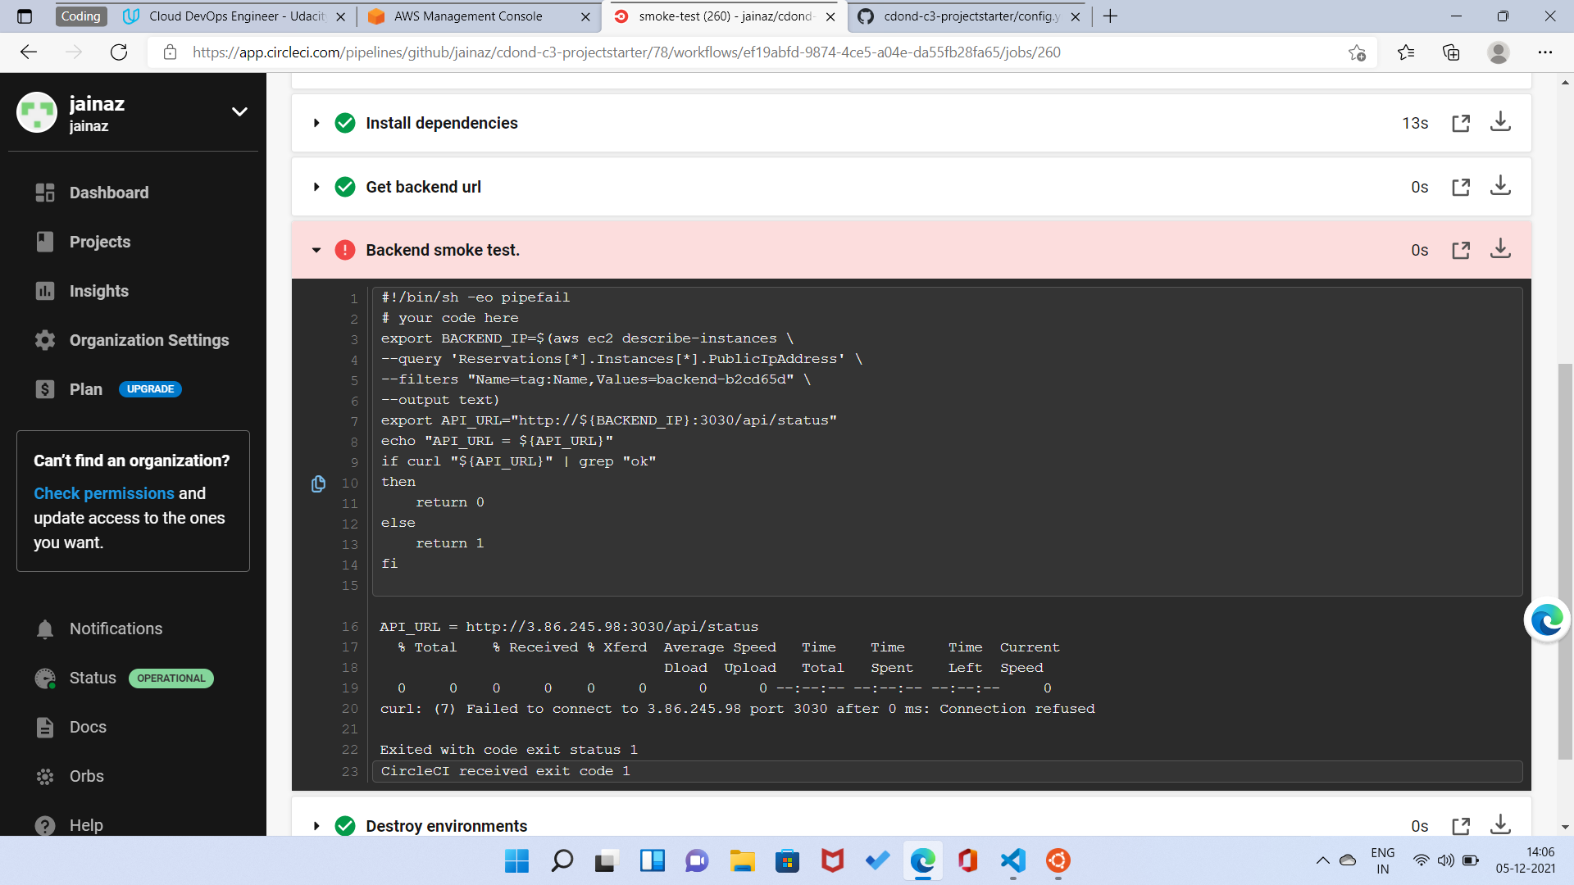

1. Successful rollback after a failed smoke test. [SCREENSHOT07]

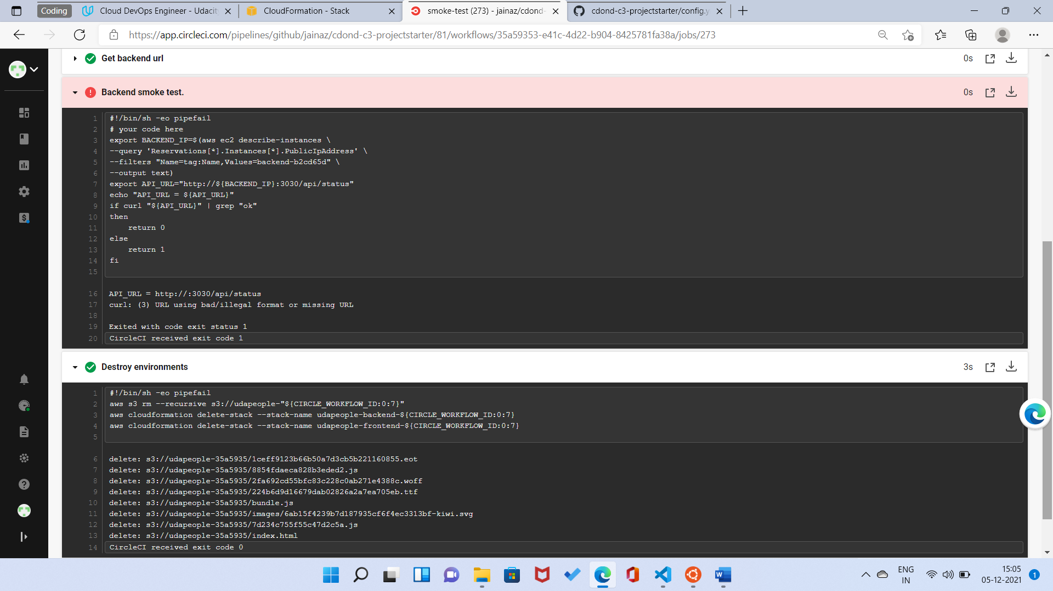

1. Successful promotion job. [SCREENSHOT08]

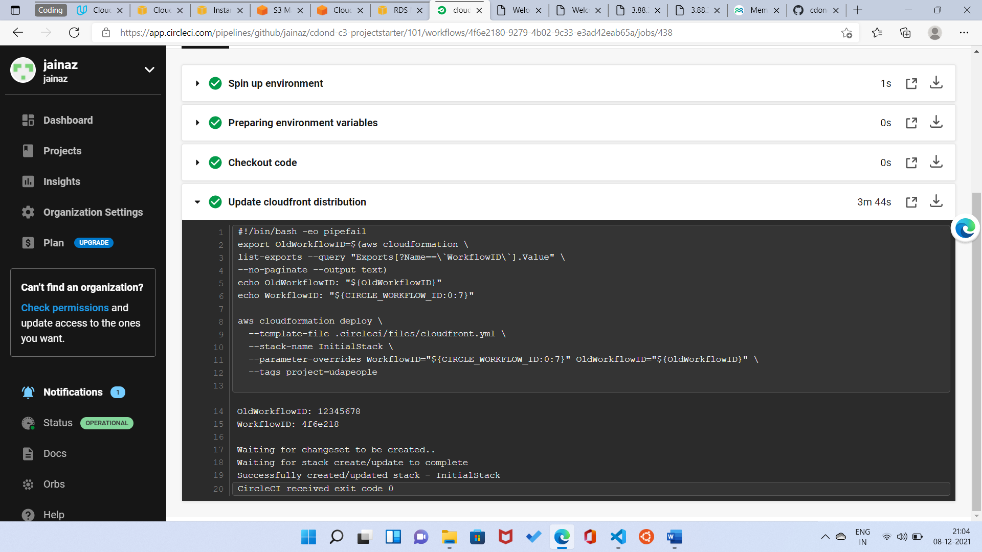

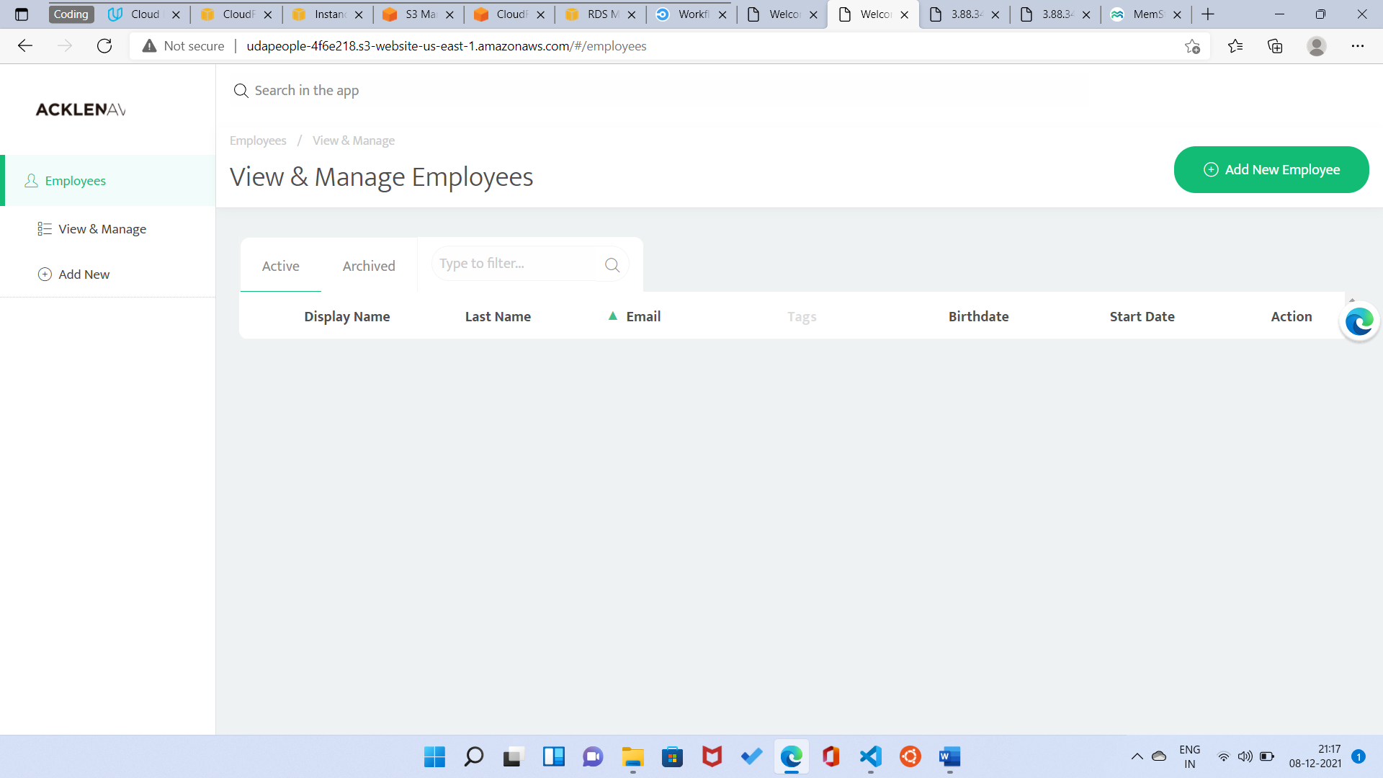

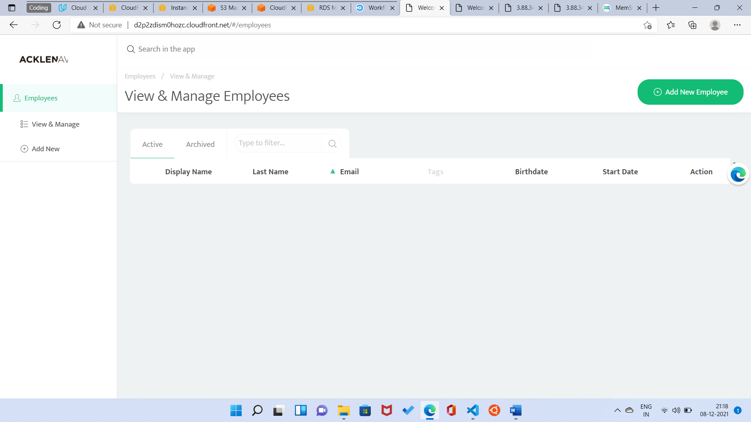

1. Successful cleanup job. [SCREENSHOT09]

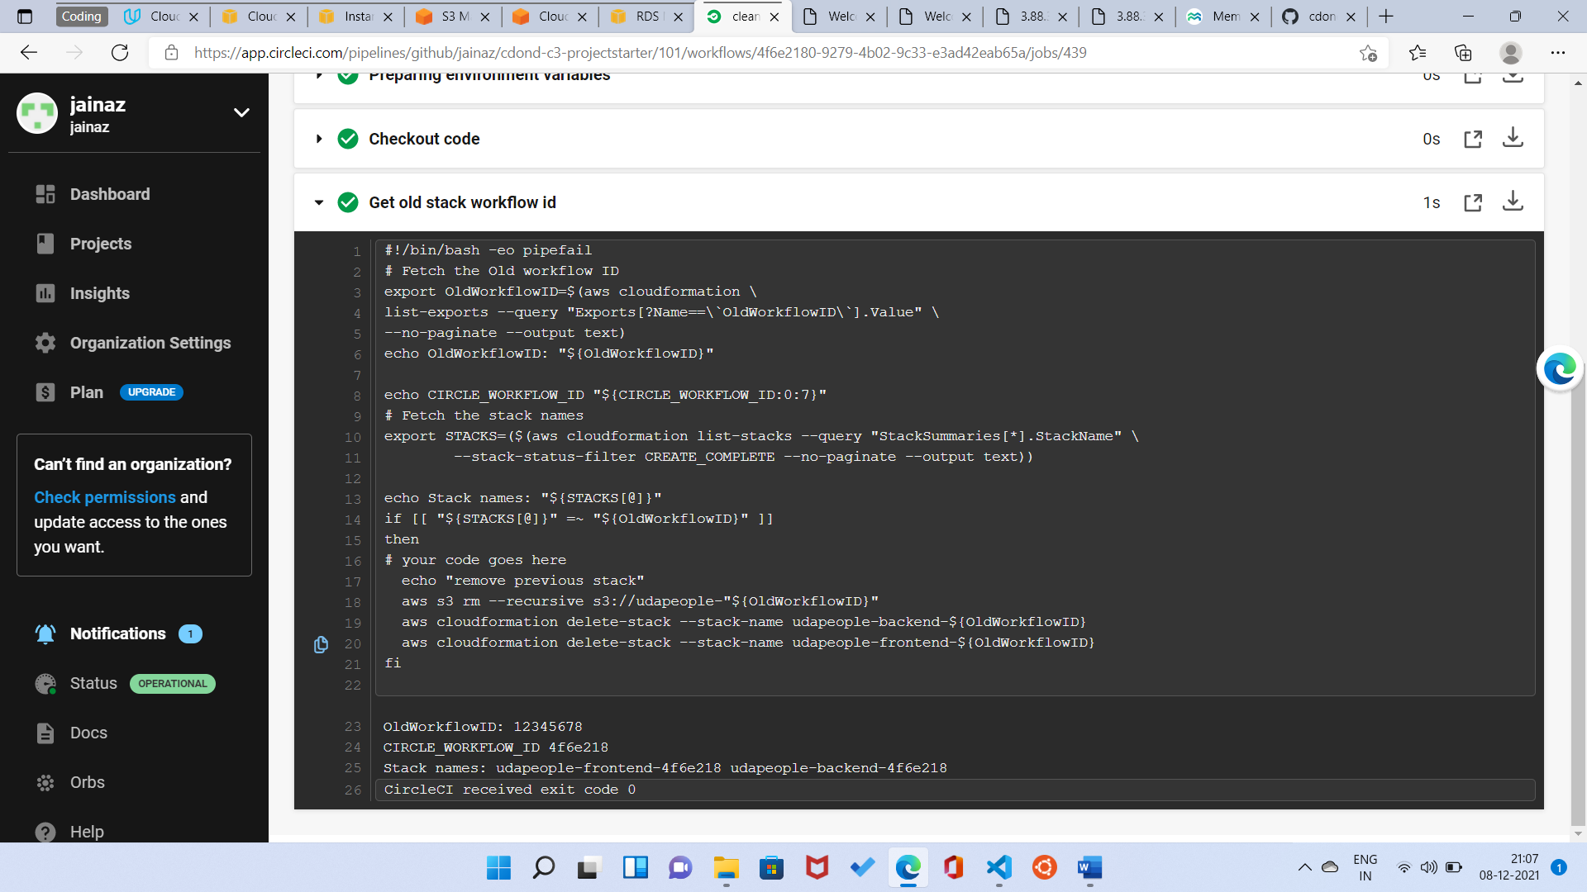

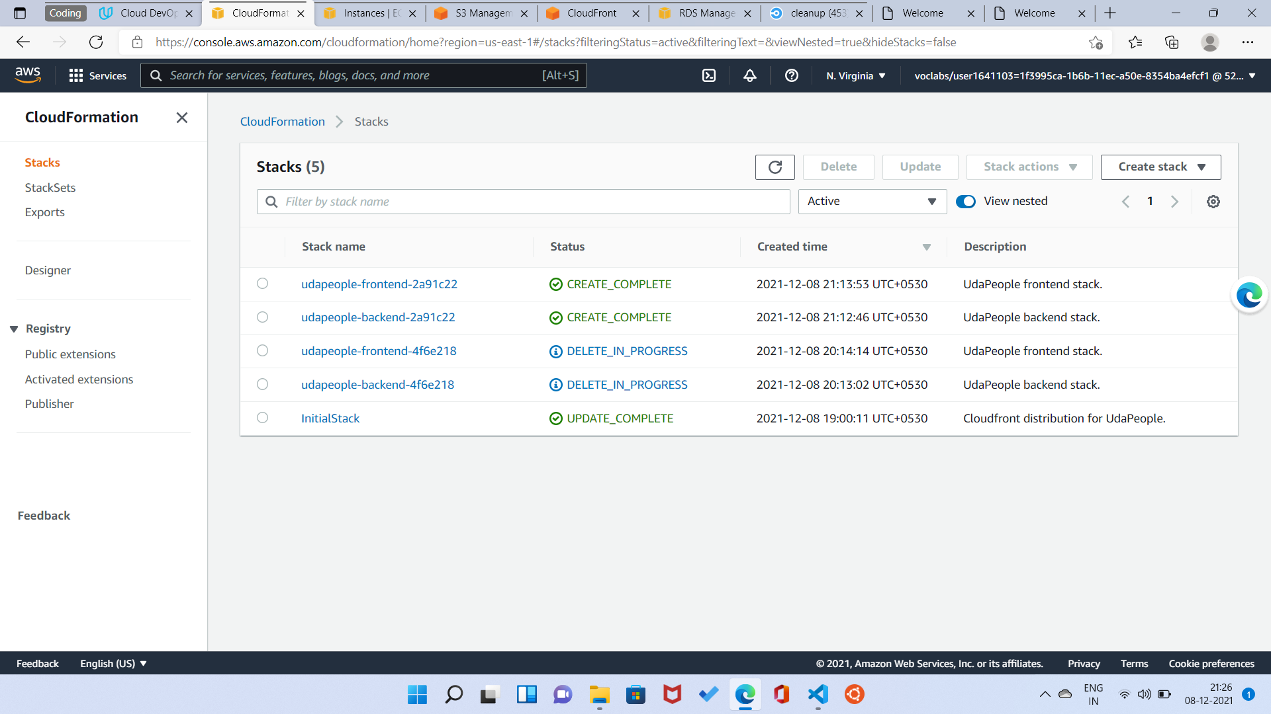

[Workflow - cdond-c3-projectstarter/102/2a91c22c-f2fe-4b16-890e-3b95157f45c1` (circleci.com)](https://app.circleci.com/pipelines/github/jainaz/cdond-c3-projectstarter/102/workflows/2a91c22c-f2fe-4b16-890e-3b95157f45c1)

1. Only deploy on pushed to master branch. [SCREENSHOT10]

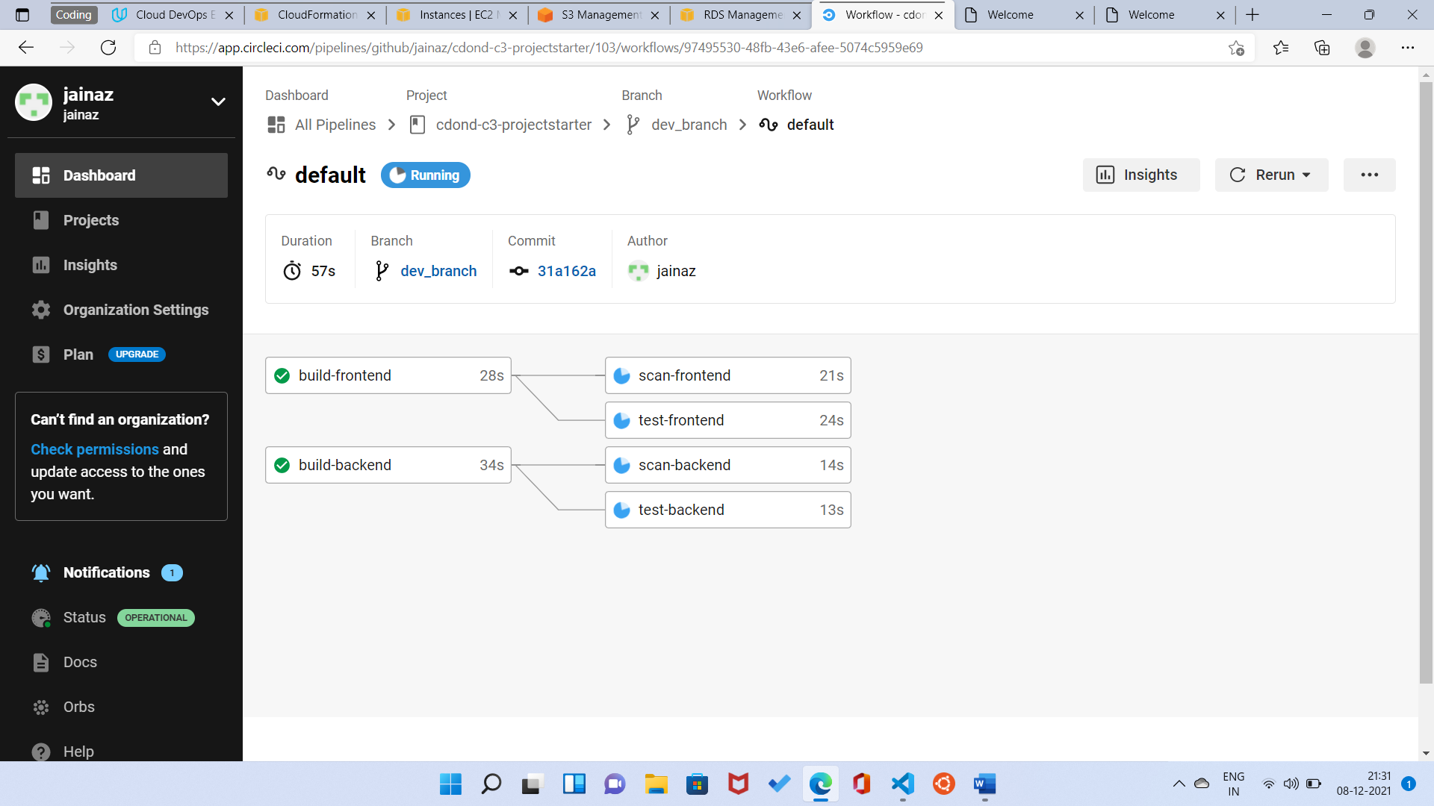

1. Provide a screenshot of a graph of your EC2 instance including available memory, available disk space, and CPU usage. [SCREENSHOT11]

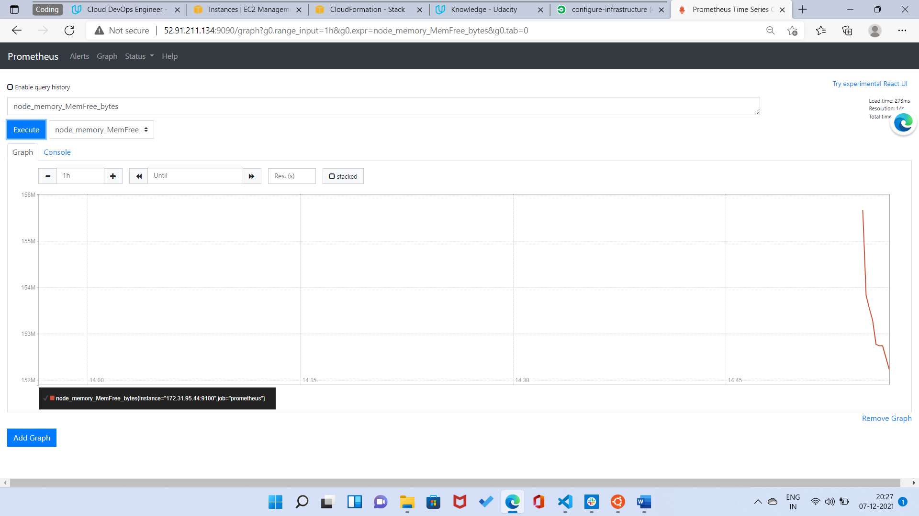

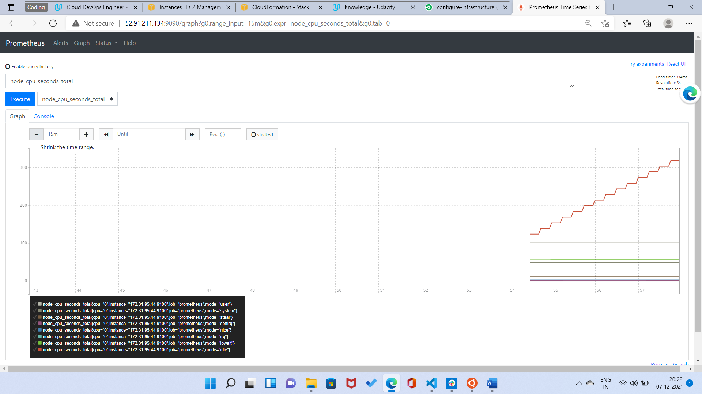

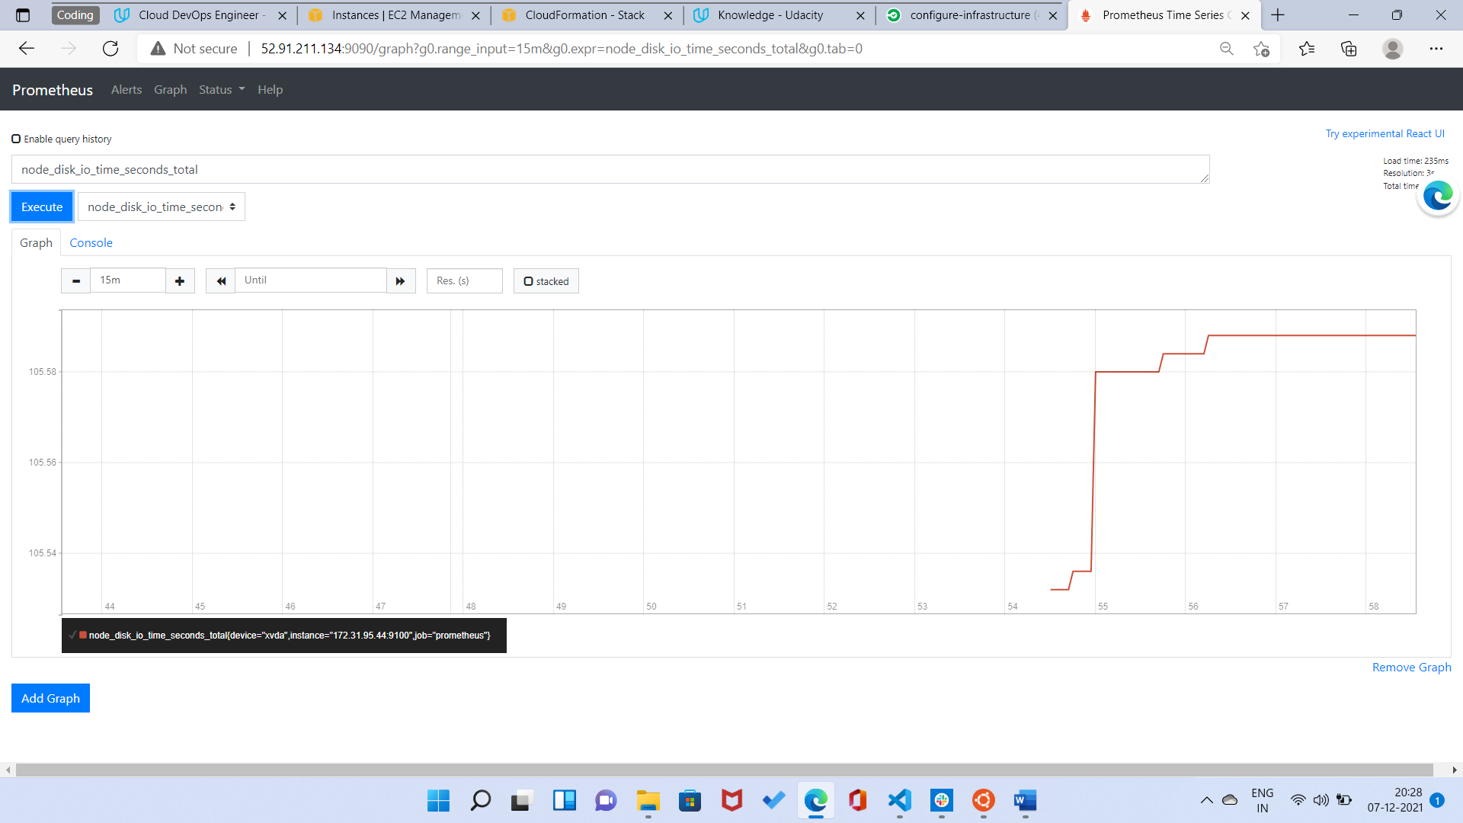

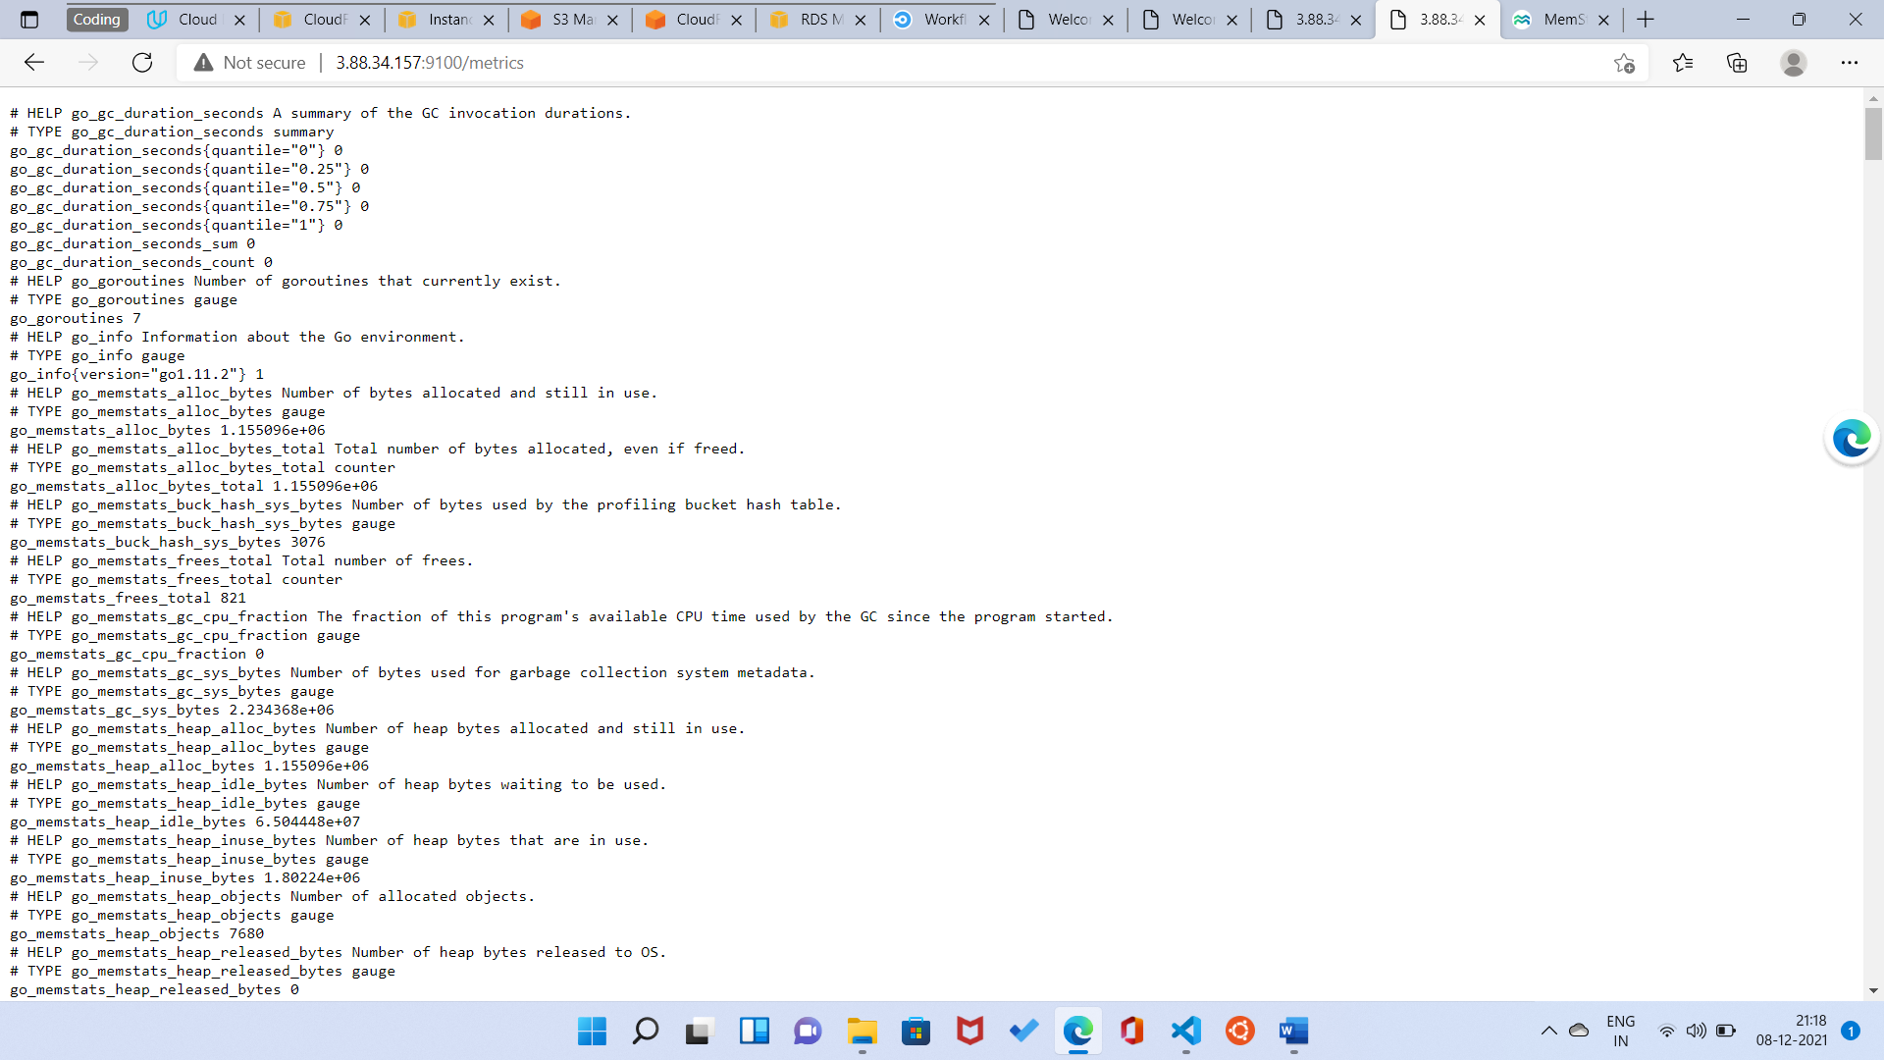

1. Provide a screenshot of an alert that was sent by Prometheus. [SCREENSHOT12]

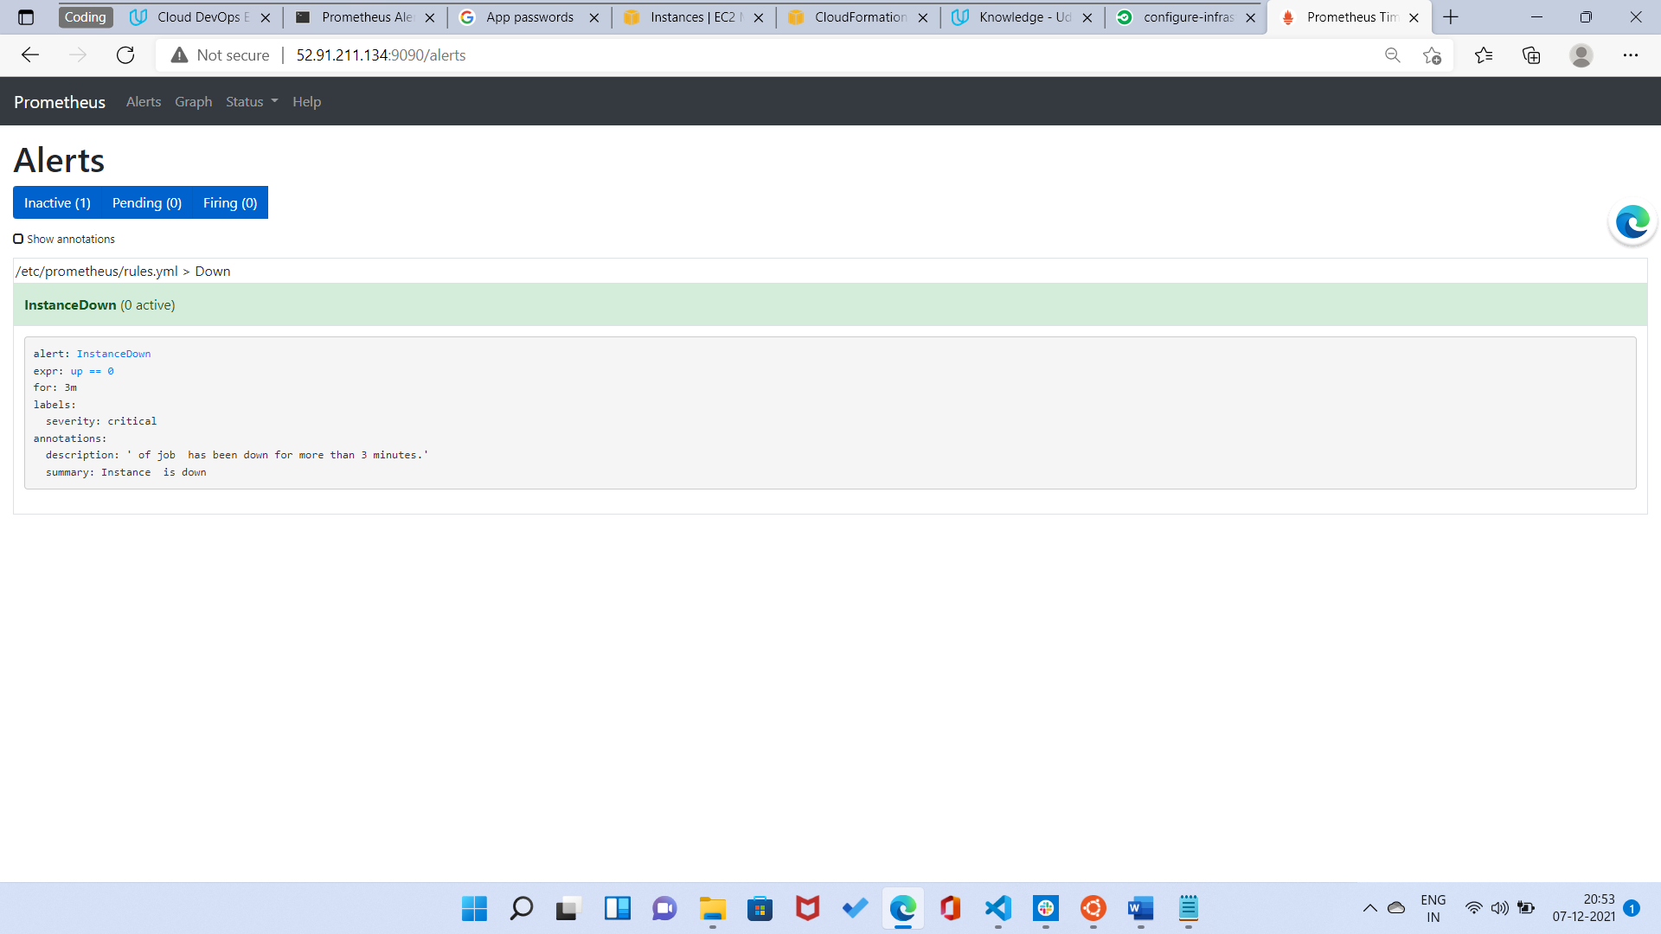

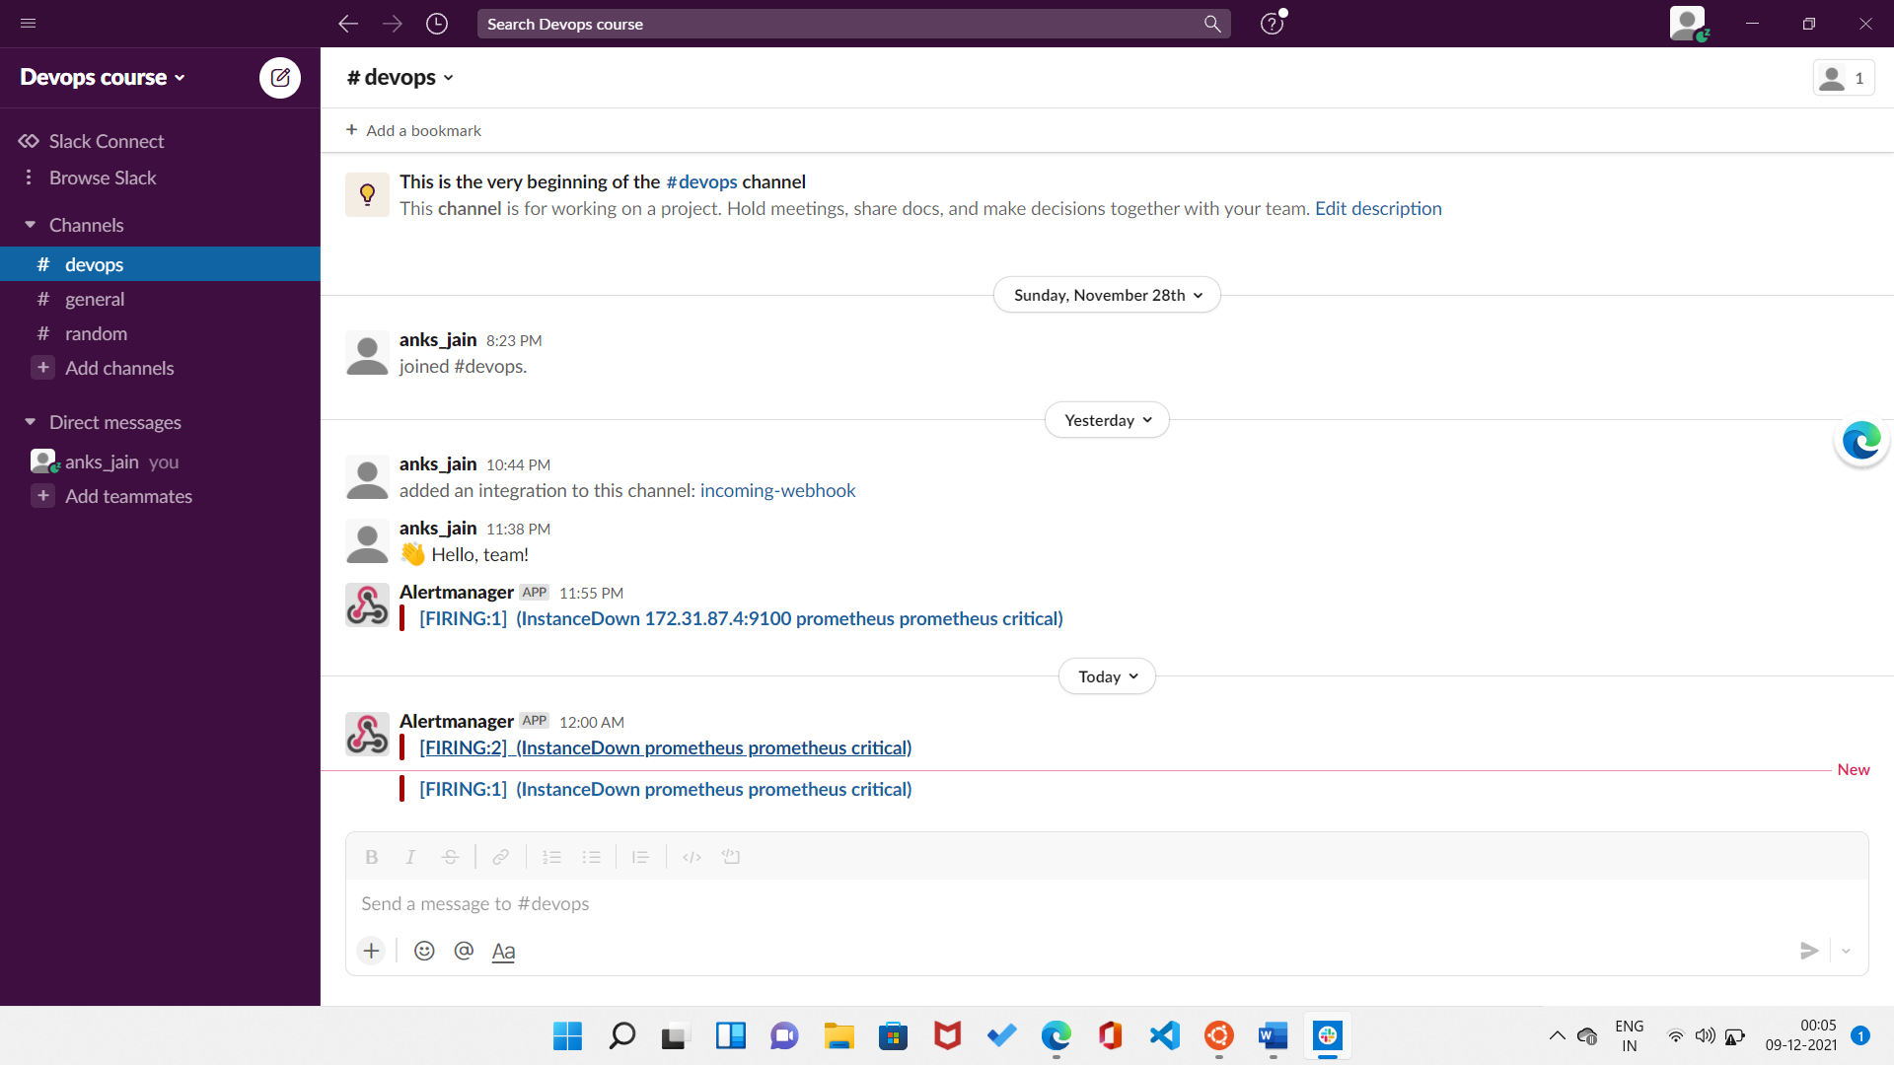

1. Provide a screenshot showing the evidence of deployed and functioning front-end application in CloudFront (aka, your production front-end). [URL03_SCREENSHOT]

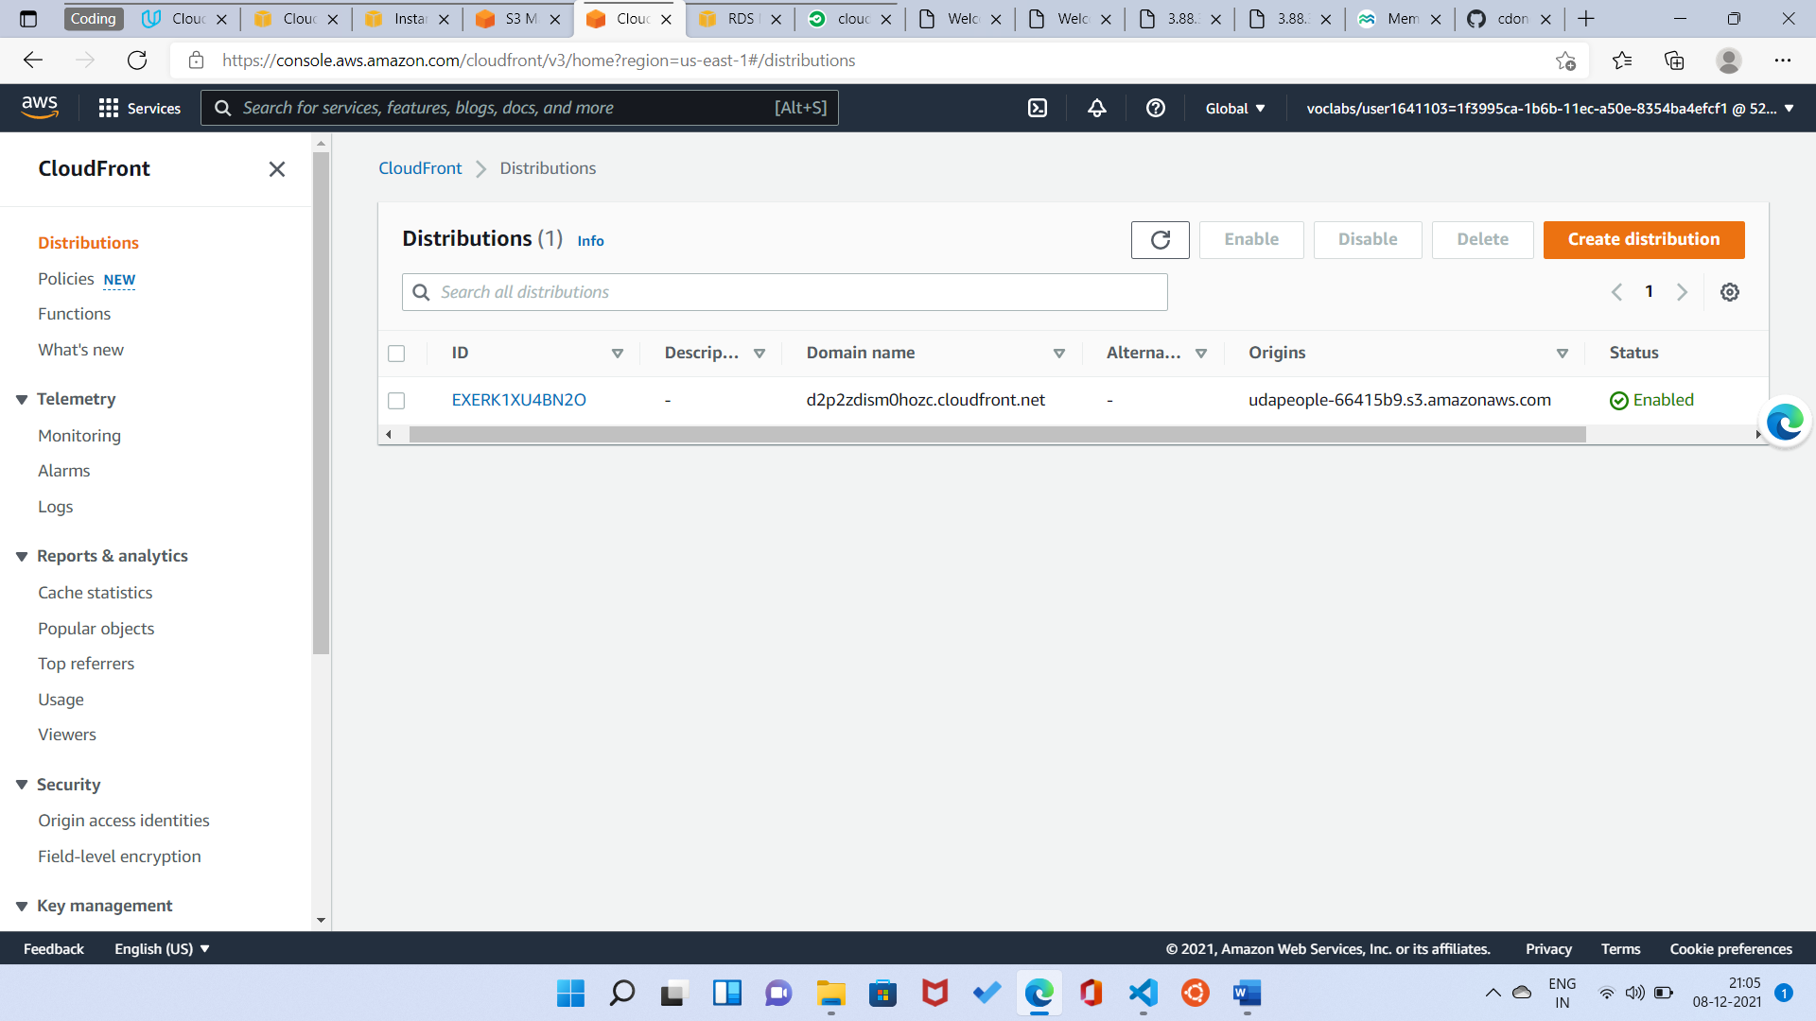

1. Provide a screenshot showing the evidence of a healthy backend application. The backend endpoint status should show a healthy response. [URL04_SCREENSHOT]

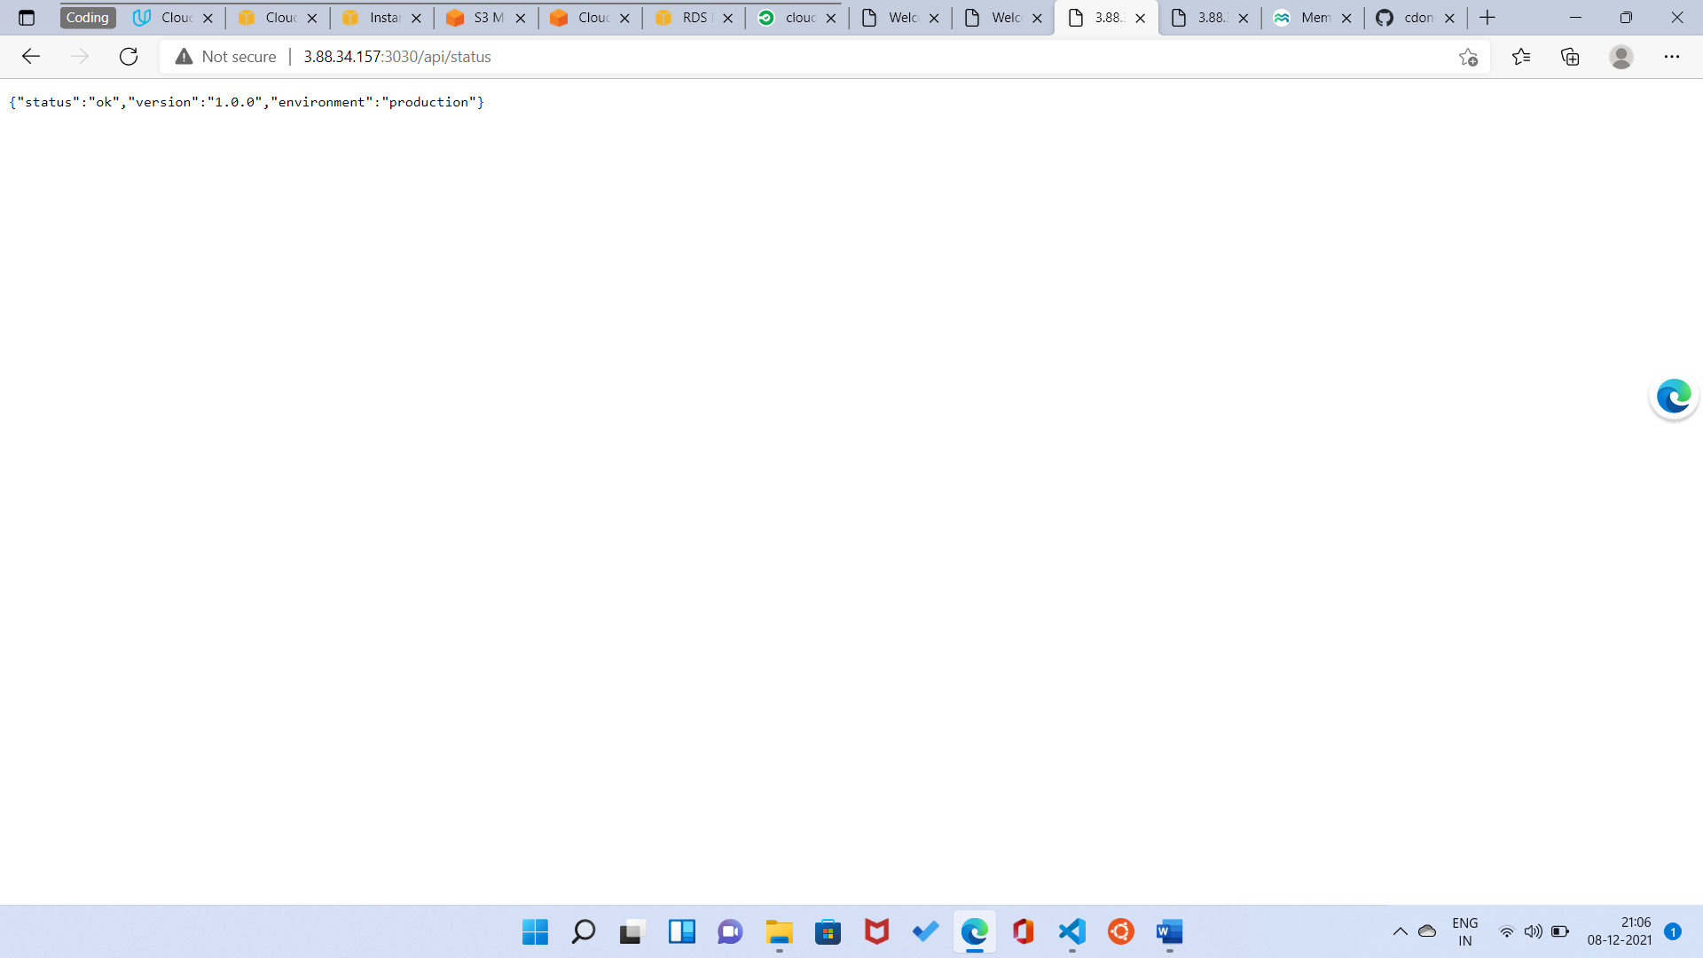

1. Provide a screenshot of your Prometheus server showing UP state [URL05_SCREENSHOT]

